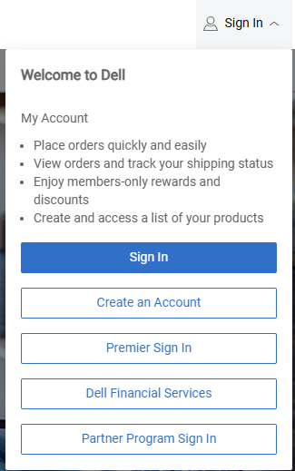
Step 1:
On Dell.com or any Dell Landing Page, click [Sign In] in the top-right.
From the Dropdown Menu, either:
- [Create an Account]
- [Sign In] to your Existing Account

Step 2:
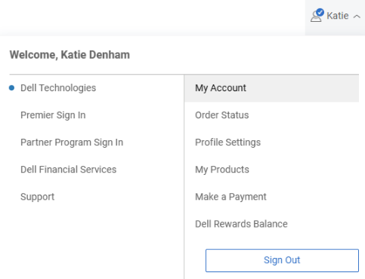
Welcome to your Dell MyAccount!
Click on your [Name] in the top-right corner
Then click, [My Account]

Step 3:
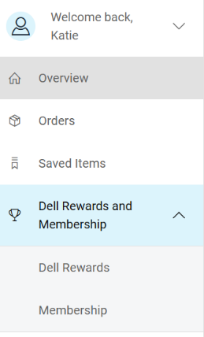
From the left-side menu,
Select [Dell Rewards and Membership]
Then click [Membership].

Step 4:

Under the Business Partnerships section,
Click [Verify Business Partnership Status].

Step 5:
Enter your Passcode (provided by your association, likely
on your Member Benefits page).

DONE: Once you [Verify Passcode] your membership will be tied to your Dell MyAccount and benefits automatically applied when shopping online

